DIS-ME-Gudea-Priest-2800-2000 BCE

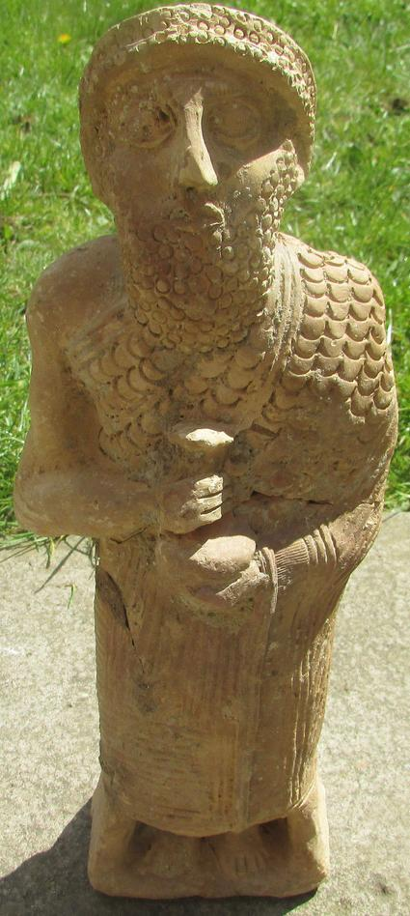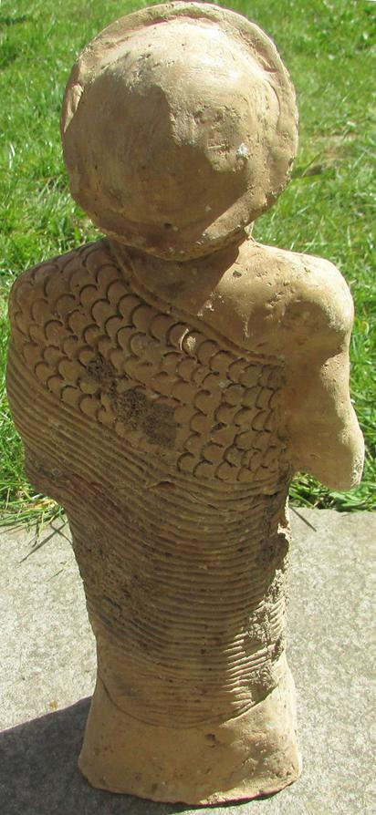

Terracotta figure of Ur-Nammu (fl. ca. 2047-2030 BCE), founder of the Sumerian 3rd dynasty of Ur and compiler of the first legal code in history. He is holding a vase overflowing with water, "au vase jaillissant," in the manner of the preceding kings of Lagash, Gudea (ca. 2144 – 2124) and his son Ur-Ningirsu (ca. 2125–2100 BCE).

This statue is of particular irony since one year-name of his reign records his devastation of Gutium, and its kings, whom he now tends to emulate as the bringer of fresh water and legal reforms: "Year in which Ur-Nammu the king put in order the ways (of the people in the country) from below to above", and "Year Ur-Nammu made justice in the land" (Ur-Nammu N.d.). His military conquests of Lagash (the seat of Gudea and his son) and Uruk established him as a competent regional ruler. He also constructed buildings at Nippur, Larsa, Kish, Adab, and Umma and restored the infrastructure of the countryside and inter-city roads after the stagnant Gutian period (Hamblin 2006). He was also responsible for ordering the construction of a number of ziggurats, including the Great Ziggurat of Ur.[[3]](https://en.wikipedia.org/wiki/Ur-Nammu" \l "cite_note-3)

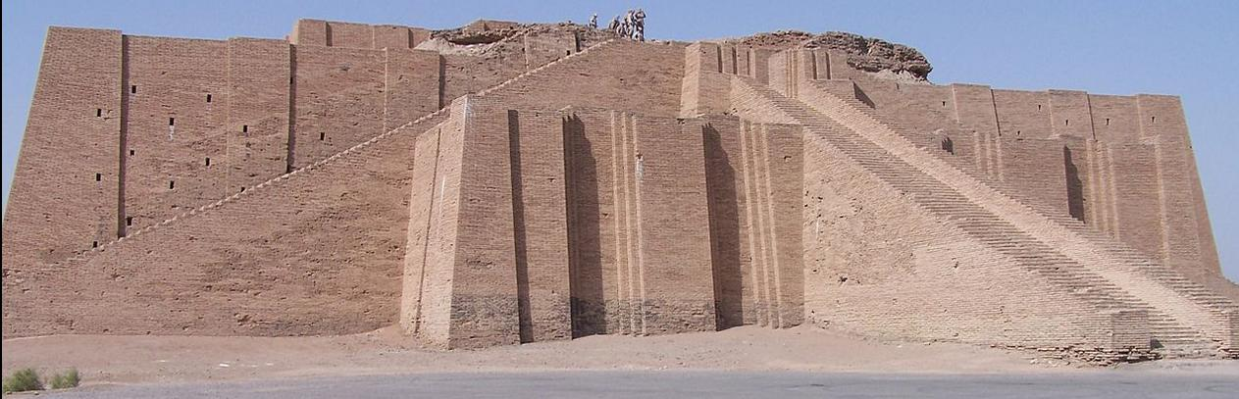

The Great Ziggurat at Ur in 2005 taken by a U. S. Serviceman. After https://upload.wikimedia.org/wikipedia/commons/thumb/9/93/Ancient\_ziggurat\_at\_Ali\_Air\_Base\_Iraq\_2005.jpg/800px-Ancient\_ziggurat\_at\_Ali\_Air\_Base\_Iraq\_2005.jpg

The Great Ziggurat at Ur which, in Sumerian *é*-*temen-ní-gùru* = “Etemenniguru” means the “temple whose foundation creates fear” (Klein 1981: 162) It was located near Nasiriyah, in present-day Dhi Qar Province, Iraq. Sir Leonard Woolley reconstructed its original state and believed a temple had been placed on its summit.

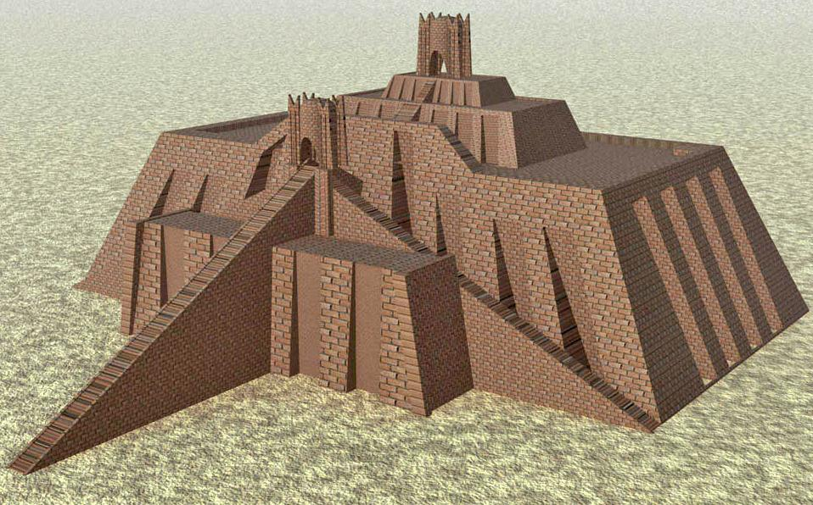

The Great Ziggurat at Ur reconstructed after Woolley in 1939.

After an eighteen-year reign he was succeeded by his son Shulgi, (ca. 2029  BCE – 1982  BCE) who completed the Great Ziggurat of Ur. His death on the battle-field against the Gutians (after he had been abandoned by his army) was commemorated in a long Sumerian poetic composition (Hamblin 2006).

This figure has a repaired crack across the upper torso. Height 31.2 cm x Width 11.3 cm

.

References:

Hamblin, William J. 2006. *Warfare in the Ancient Near East to 1600 BC*. New York: Routledge, 2006.

Klein, Jacob. 1981. *Three Šulgi hymns: Sumerian royal hymns glorifying King Šulgi of Ur*, Bar-Ilan University Press.

Ur-Nammu. N.d. [Year-names for Ur-Nammu](http://cdli.ucla.edu/tools/yearnames/HTML/T6K1.htm).

Woolley, C. Leonard. 1939. The Ziggurat and its Surroundings. Ur Excavations. London ; Philadelphia : British museum : University Museum. **Vol. 5**.

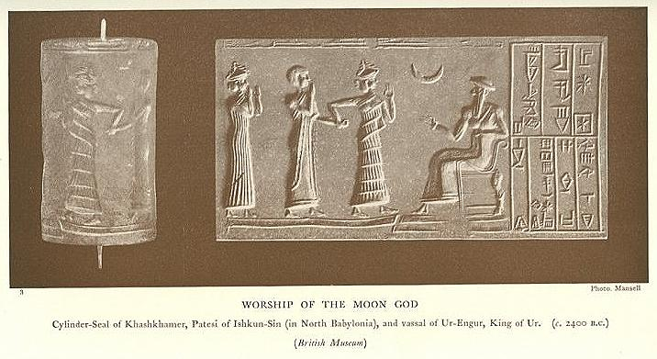

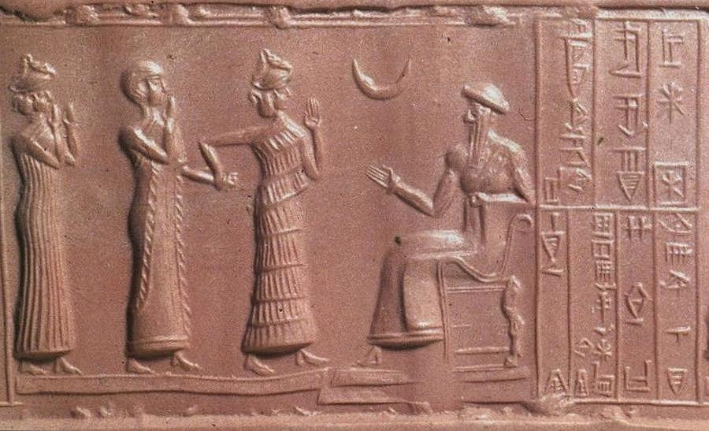

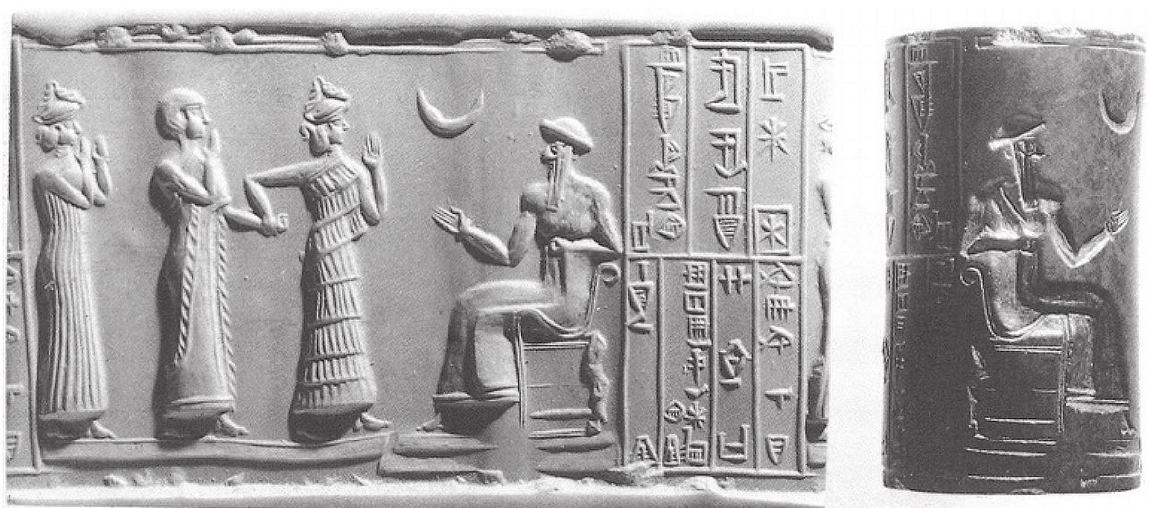

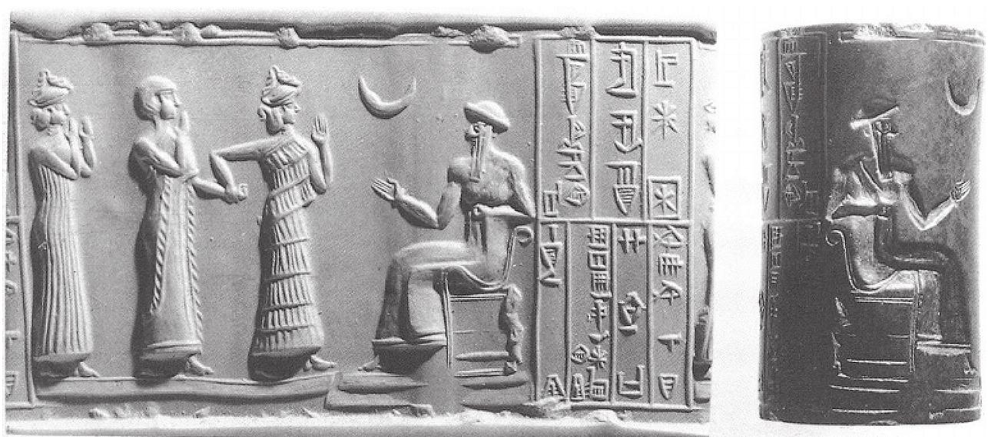

Cylinder seal impression of Ur-Nammu (fl. ca. 2047-2030 BCE), founder of the Sumerian 3rd dynasty of Ur and of the first legal code in history, seated on a throne beneath the crescent moon sign, the astral representation of the Sumerian moon-god Nanna/Sîn ( DŠEŠ.KI, DNANNA), the son of Enlil and Ninlil. Nanna later became identified with the Semitic Sin moon god who, following the conquests by the founder of Akkad by Sargon (2334–2279 BCE) the two became syncretized. Nanna/Sin worship centers were Ur in the south of Mesopotamia and Harran in the north. In the cylinder seal Ur-Nammu greets a *lamassu* or protective goddess who is leading the owner of the seal, ašamer, on whom the *ensi* or [pa](https://en.wikipedia.org/wiki/Pa_(cuneiform)).[te](https://en.wikipedia.org/wiki/Te_(cuneiform)).si, , a local governorship of Iškun-Sin in southern Mesopotamia is being bestowed following the end of Gutian rule. The inscription on this cylinder seal impression reads – “Ur Nammu, the mighty hero, king of Ur, ašamer the governor of Ishkun-Sin his servant”.

Original: British Museum (WA.89126), Ref.: MacKenzie 1915: 50. Donald A. Mackenzie, *Myths of Babylonia and Assyria* (London: Messrs. Mansell & Co., 1915), p. 50.

Width - 9 cm / 3-1/2 inches; Height - 5.5 cm / 2-1/4 inches

U**r-Nammu** (or **Ur-Namma**, **Ur-Engur**, **Ur-Gur**, ca. 2047-2030 BC [short chronology](https://en.wikipedia.org/wiki/Short_chronology)) founded the [Sumerian](https://en.wikipedia.org/wiki/Sumer) [3rd dynasty of Ur](https://en.wikipedia.org/wiki/3rd_dynasty_of_Ur), in southern [Mesopotamia](https://en.wikipedia.org/wiki/Mesopotamia), following several centuries of [Akkadian](https://en.wikipedia.org/wiki/Akkadian_Empire) and [Gutian](https://en.wikipedia.org/wiki/Gutian_period) rule. His main achievement was state-building, and Ur-Nammu is chiefly remembered today for his [legal code](https://en.wikipedia.org/wiki/Legal_code), the [*Code of Ur-Nammu*](https://en.wikipedia.org/wiki/Code_of_Ur-Nammu), the oldest known surviving example in the world.**Ensi** (spelled [pa](https://en.wikipedia.org/wiki/Pa_(cuneiform)).[te](https://en.wikipedia.org/wiki/Te_(cuneiform)).si, in [cuneiform script](https://en.wikipedia.org/wiki/Cuneiform_script), hence occasionally transliterated "patesi"; possibly derived from [en](https://en.wikipedia.org/wiki/EN_(cuneiform)) si-k, "lord of the plowland";[[1]](https://en.wikipedia.org/wiki/Ensi_(Sumerian)" \l "cite_note-1) borrowed into [Akkadian](https://en.wikipedia.org/wiki/Akkadian_language) as *iššakkum*) is a [Sumerian language](https://en.wikipedia.org/wiki/Sumerian_language) title designating the ruler or prince of a [city-state](https://en.wikipedia.org/wiki/City-state). Originally it may have designated an independent ruler, but in later periods the title presupposed subordinance to a [lugal](https://en.wikipedia.org/wiki/Lugal).

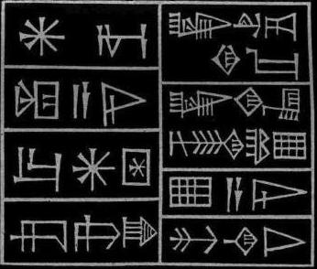For Inanna/ His queen/ Ur-Namma/ The mighty man/ The king of Ur/ The king of Sumer and Akkad/ Her temple/ He built

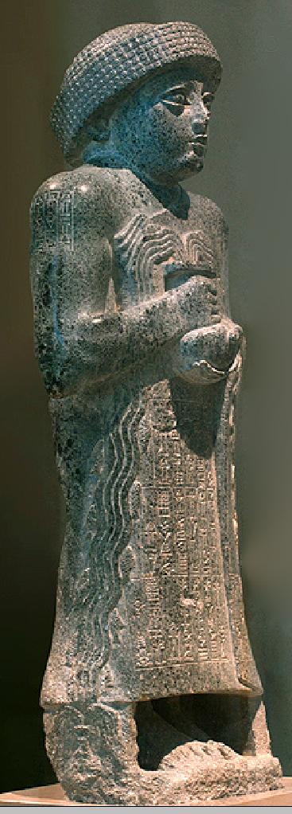 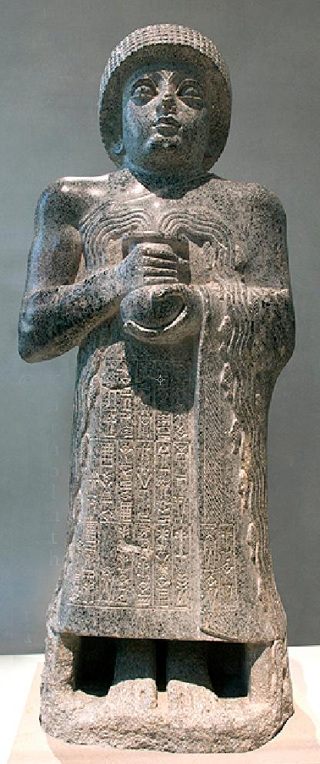

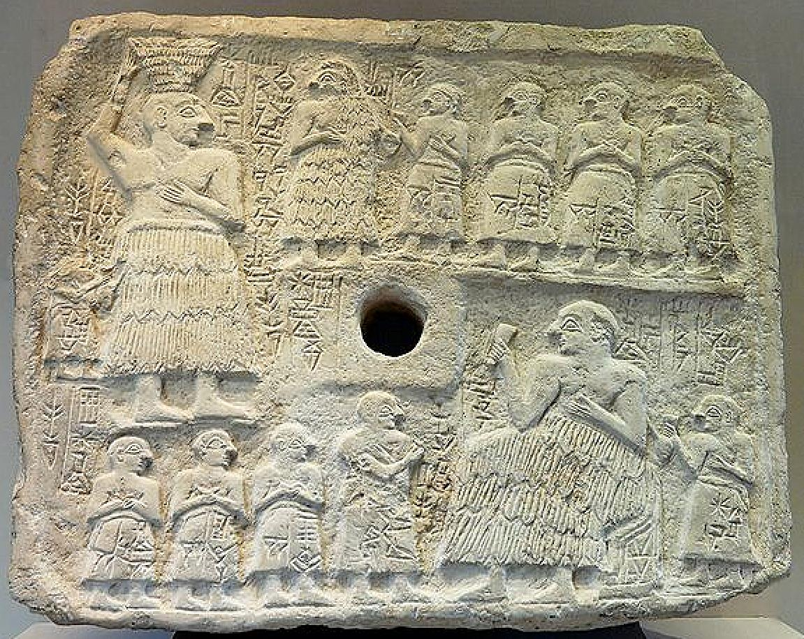

Votive relief of Ur-Nanshe, king of Lagash, Early Dynastic III (2550–2500 BC). Limestone, Height: 39 cm (15.4 in). Width: 46.5 cm (18.3 in).

Louvre (Department of Near Eastern Antiquities), room 1a: La Mésopotamie du Néolithique à l'époque des Dynasties archaïques de Sumer. Louvre Musée, Richelieu, ground floor. 1888: excavated by Ernest de Sarzec. Place: Ĝirsu (**Ngirsu**, near the modern city of Telloh, Iraq).